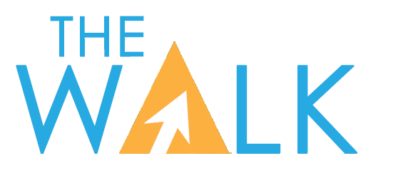

TW Broadcasting LLC
3409 Rutherford Road Extension
Taylors, SC 29687
864-244-1616 voice

CHILDREN’S PROGRAMMING CERTIFICATION FOR FOURTH QUARTER 2025

This is to certify that The Walk Television Network is a television programming network distributed to affiliated stations in the United States via satellite. As a standard practice, the network formats and airs the following children’s programs and series so that the total commercial time is less than 10.5 minutes per hour on weekends, and 12 minutes per hour on weekdays, and that the E/I logo is continuously displayed onscreen for the duration of all programs in compliance with the Children’s Television Act of 1990 and the rules and regulations of the Federal Communications Commission (“FCC”).

Children’s E/I Program’s Aired During Fourth Quarter 2025

I hereby declare, under penalty of perjury, that the foregoing is true and correct.

Dog Tales
Scaly Adventures
Biz Kids
America’s Heartland
Elizabeth Stanton’s Great Big World
Think Big
iShine Knect
Animal Rescue

Descriptions, time and dates, preemptions and target audience of each program may be seen on the separate attachment.

The minimum amount of regularly scheduled E/I programming available to affiliated stations per week this quarter is four hours per week.

/s/ Greg West
TW Broadcasting, LLC
January 2026

